Functionality Questionnaire

User registration:

1) Could you please describe the functionality of registration process for following scenarios i.e. for a) very new customer and b) customer with label (where would he get the label from) and when will these customer would be directed to payment process?
Comments: Members will receive labels directly from our partners, therefore 95% of new members are simply coming to the site to register their unique code. For example, our partners may have stickers from 1,000 - 5,000, so selected individuals with labels between these numbers would visit our site to register their numbers. We wanted to offer people an option to order additional stickers if they needed them, or if they didn't already have them. In both cases, the people would enter their contact information at which point they would be directed to they payment process. In the case where the person already had a sticker they would enter the unique code which would be associated with their contact details. In the case where they are requesting a new sticker their contact details would be associated with a set of unique codes that we retain one of which would be associated with their contact details. Subsequently, they would be send the stickers with the codes associated with the stickers they requested.

For the above statement “Members will receive labels directly from our partners” our understanding is that, labels would be provided by your partner manually through mail/phone to the person who is requesting them. We are assuming that user will request this label through website “click here to register” link and in-turn; we would need to re-direct him to payment gate way for label requested from partner.

In case, we are not charging for the label that user requesting from site after providing contact details, below are the scenarios we would think about.

#1. Person may or may not return to site to register his label
#2. We would need to set the label to the details provided by the user and need to associate a label on his name (reserve it for him) till he get back to register.
#3. What if he ignores our mail sent with label?

No, this is not the case. The labels will be giving to people directly through events and retail outlets free of charge. The people WILL NOT come to the website to request labels initially, however they may come to the site to request additional labels or if for some reason they have not received labels at a retail outlet or at an event. Serial Number will not be reserved with a name and address, but the record for this serial number will remain blank until a person visits the site to register. We expect 2-3% of the Serial Number to be registered.

#1 You are correct.
#2 No, Serial Number are not reserved at we will not have contact details in order to do so. These records will remain bland until a person visits the site to register their label
#3 If the person does not visit the site then the record will remain blank. After a specified period (most likely >1year) another label with the same Serial Number may be reissued.

-----------------------------------------

Once, the payment process is success, we are assuming that user would need to enter this unique code in the text box provided to register on site, which would be associated with their contact details internally.

Here, We are assuming that once user enters his unique label then would be re-directed to contact details then to member ship package details (3 or 1 year package) then to payment gate way.

#1 First the person would enter the Unique Serial Number, then be asked to provide their contact details, and finally be re-directed to the payment process. Our PayPal account is currently sales@recoverlink.com. We want to capture their details first, incase the payment process is interrupted for some reason we could contact them directly.

2) Please describe the below functionality
http://www.returnit.com/get_started.php

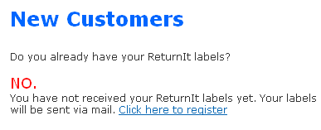
Comments: We wanted to offer people an option to order additional stickers if they needed them, or if they didn't already have them. In both cases, the people would enter their contact information at which point they would be directed to they payment process. In the case where they are requesting a new sticker their contact details would be associated with a set of unique codes that we retain one of which would be associated with their contact details. Subsequently, they would be send the stickers with the codes associated with the stickers they requested.

3) Please describe the below functionality
http://www.returnit.com/get_started.php

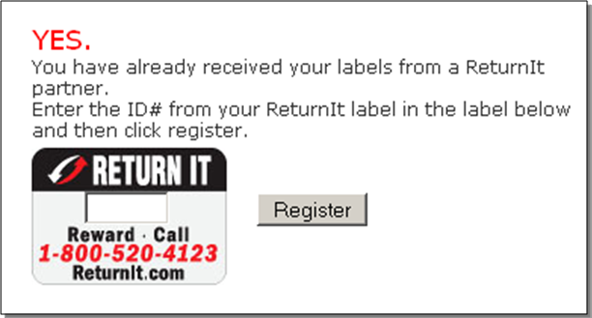

Comments: Members will receive labels directly from our partners, therefore 95% of new members are simply coming to the site to register their unique code. For example, our partners may have stickers from 1,000 - 5,000, so selected individuals with labels between these numbers would visit our site to register their numbers. In the case where the person already had a sticker they would enter the unique code which would be associated with their contact details. In both cases, the people would enter their contact information at which point they would be directed to they payment process.

LABELS:

4) We are assuming that a random unique serial number will be generated on successful registration to the site and each customer will have his unique ID to recognize and he may have multiple number of labels (codes) attached to his account. Is this correct?
Comments: No this is not correct. We will know the range of serial numbers given to each of our partners. For example, partner #1 may have code from 00010000 - 00012000, so we would know that we need these 2,000 records created in the database. Then when someone with one of the specific serial numbers (i.e. Serial number 00010108) will come to the website, enter this number 00010108 then be prompted to enter their contact details. We need to capture this information and associate it with record 00010108, then send them to the payment process to complete registration. In the case where a person does not have a Label, or they are requesting additional Labels they obviously do not have a serial number to enter so we would simply take their contact details and assign it to one of the records of the serial numbers that we have reserved internally. For example, Labels with serial numbers 00000000 - 00001000 might be kept within the company then be assigned to people requesting Labels through the website. The serial numbers associated with these Labels would then be assigned to a person and mailed out to them directly. These could be assigned sequentlaly if it make the process easier.

Person requesting additional labels:

If we are guiding the user to follow the same process as person coming to our site very first time to request label, then below might be the issues that we would need to think about:

1) We would need to differentiate each request whether it is ordered by a new user or existing user ordering for more.

#1 The difference would be that a person with Labels would enter their Unique Code First (which would indicate they have a label they’d like to register) A person requesting new labels would jump directly to the second step of providing their contact details then being directed to the payments process. We would assign a Unique Code at the end of the transaction and the associated label would be sent to them directly.

2) we would need to link the labels on the basis of his contact details which involves a huge process.

#2 I think and easier method would be to have each record be associated with a Unique Code (Serial Number) and duplicate contact details as necessary to multiple records is the person requests additional labels. This will eliminate the arduous process you’re describing. Lets try to keep this as simple as possible.

3) what if the contact details that were provided by existing user is little different first time, from the details entered for requesting more labels. If so there is a chance of creating a new account for existing user.

#3 if we direct them to Log In first, this would not happen. If however they don’t Log In first, then yes it is a possibility, however this should not be an issue since each Unique Code is a record, and essentially a person would have a new account for each label requested. Or we could ask them if they have any other Unique Code and associate multiple records with a single account with a foreign key.

To get rid of these issues, we are thinking that existing user would need to order for more labels from his account by login, as our current site is doing
http://www.returnit.com/
So that we could recognize which account user is requesting the labels, so that we could append those labels to his account. Attached is the screenshot displaying the same

#4 Yes, I agree with this. See above.
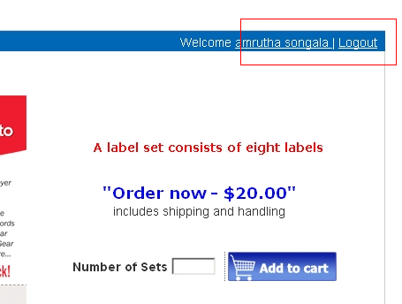

5) What are asset tag and how they are linked to Labels?
Comments: These terms are used interchangably and mean the same thing. We should probably just use the term Label everywhere to eliminate confusion. All labels will have an 8 digit serial number with the first two digits being the year the tag was issued for example 11000000, 11000001, 11000002, etc., etc.

6) Labels - how will we manage Labels in site, how can user add more than one labels to his single account? How will user get the second label or more labels from user account? Will these multiple labels of an single account a unique number (or) labels with different numbers?
Comments: All labels are unique, so therefor if a person comes to the site to register a serial number 11000015 and they are requesting additional Labels they obviously do not have a serial number to enter so we would simply take their contact details and assign it to one of the records of the serial numbers that we have reserved internally. For example, Labels with serial numbers 00000000 - 00001000 might be kept within the company then be assigned to people requesting Labels through the website. The serial numbers associated with these Labels would then be assigned to a person and mailed out to them directly. These could be assigned sequentlaly if it make the process easier.

7) Could you please describe this with a example the following functionality “Each unique serial number will be associated with an asset tag, and therefore it will not be a randomly generated number, but rather a number enter by the user upon registration. My get is that this could be handled either by an append or update query in the database.”
Comments: A person is given Label with number 11000015. They place this Label on their phone. They visit our website to register this Label. They enter serial number 11000015 then provide their contact details at which point they are directed to the payment process. Once their contact details have been entered and payment has been processed then the record 11000015 would be updated in the database with their contact details. The person therefor provides the serial number (database record) that their contact details would be associated with.

8) Could you please describe “ It will be important for users to be able to register their unique code with their personal contact details and for that to be automatically saved into a database”
Comments: A person is given Label with number 11000015. They place this Label on their phone. They visit our website to register this Label. They enter serial number 11000015 then provide their contact details at which point they are directed to the payment process. Once their contact details have been entered and payment has been processed then the record 11000015 would be updated in the database with their contact details. The person therefor provides the serial number (database record) that their contact details would be associated with.

Accounts:

9) User has to agree to there auto package renewal option - Should we need to display this in the registration page?
Comments: Yes, when the user signs up they will sign up for a one-year period which will automatically renew at the end of each year for another one-year period, unless the call or email to end the membership.

10) Auto renewal process would work for only for active accounts (customer with the active credit card details) when the cron job finds that Customer credit card is expired on payment date, that account would be moved to Inactive state. However, when user logins to account, he would be able to see his”MY account” section only, where he would need to update CC details (would be restricting to visit other sections) and “make payment” button to make payment. Please let us know your thoughts here. Also, we are planning to display the next expiry date of his package in prior in customer account at package details.

Comments: Yes that is correct and the functionality sounds like it would work. We should have sometime of flag in the database that would indicate whether a serial number (and associated member) was active or inactive.

11) Is there any intimation that needs to be sent to customer email address that your payment got process on payment date after successful payment?
Comments: That's a good question. I think we should have the ability to send out emails to members upon successful payment. Obviously, we would want ability to change the content of this email as needed.

12) Could you please describe in detail with example for “Customers should be able to add additional codes or replace lost codes with new ones” Can a single user (with unique ID) account may have a multiple codes? And can add other codes too?
Comments: Yes all serial numbers are unique so if people register additional Labels they will be registering additional unique serial numbers, therefor one individual could be associated with multiple serial numbers. One option is the person would have to reenter their contact details each time the registered a new Label (and associated serial number) or the second option would be that if we could identify a person who was already a member was requested additional labels or simply register new labels they have received we might be able to prepopulate the contact information for them to speed the registration process for additional labels.

13) How would a person who found the item would contact our Recovery link? Is there any information that he needs to provide on the site?
Comments: Yes, the person who found an item would first enter the serial number of the item they found and then provide their contact details. We would want to capture these contact details in the database and associate them with finding a particular Label (or serial number). The contact details for the person who found the item would then be sent via email to the member associated the serial number and item that was just found.

14) RECOVER LINK TO SEND THE PERSON WHO FOUND THE ITEM THEIR ADDRESS AND BILLING NUMBERS SO THAT THEY MAY MAIL THE ITEM DIRECTLY TO THE OWNER IF THEY ARE NOT LOCATED IN CLOSE PROXIMITY TO EACH OTHER. THERE WOULD BE A ONE-TIME FEE OF $19.95 TO COVER SHIPPING COSTS OF THE ITEM. (THIS WOULD BE INCLDUED IN THE $29.95 CHARGE IF THE MEMBERSHIP HAD EXPIRED)

#14 To simplify this process, I have tried to explain this through a workflow chart that was attached to my last email. I will also attach it to this email. To simplify this process we will have all items returned directly to RecoverLink if the member prefers not to meet directly with the Samaritan to exchange the recovered item. The Samaritan will be notified via email to return the item directly to RecoverLink. This email will also include a mailing label they can use with the company address. All the Samaritan has to do s put the item in a box or envelope, print the return mailing label, and mail the item back to RecoverLink.

In the statement above, how would we send the Recovery link to the person who found the item lost and their address? How would we need to charge the item owner of $19.95 to cover shipping and $29.95 for non active customer? Whose billing address may or may not be right as per records updated by the non active customer. Also, on what basis we are going to charge the item owner? Is there any acknowledgement / call that we are going to receive from the item owner after successful delivery?
Comments: I'm not sure of the answers to these questions and will need to think through them more clearly with Jason to define this functionality more clearly for you. We will get you this description tomorrow.

15) Could you please explain us on “May need the ability to download a shipping label for return of lost items”.
Comments:

